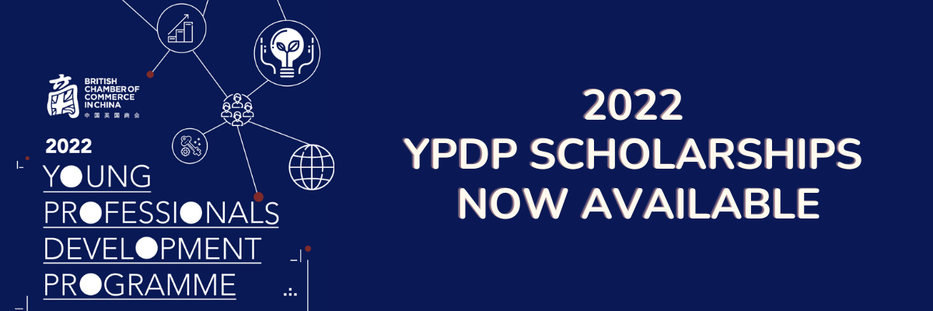
YPDP 2022 Scholarships

BritCham China is offering two full scholarships for YPDP 2022!

These scholarships will be granted to exceptional candidates who have relevant experience in UK-China relations, and who we feel would make an excellent contribution to the programme.

To apply, fill out this form or send the following details to youngprofessionals@britishchamber.cn before 26 August (applications will be judged anonymously and winners announced 31 August):

Full name

Date of birth

Company

Job title

500 words (maximum, in English) about your experience in UK-China relations and your motivation to join the Young Professionals Development Programme.

