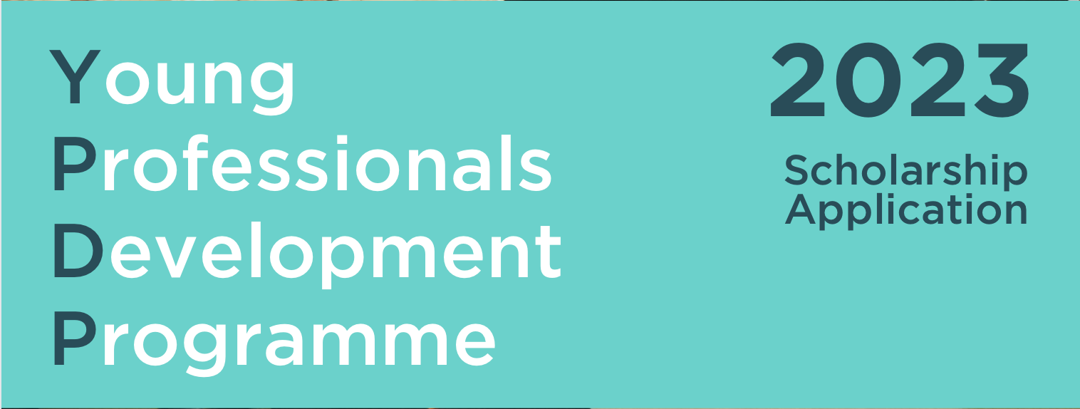
YPDP 2023 Scholarships
BritCham China is offering two full scholarships for YPDP 2023!
These scholarships will be granted to exceptional candidates who have relevant experience in UK-China relations, and who we feel would make an excellent contribution to the programme.
To apply, fill out this form or send the following details to youngprofessionals@britishchamber.cn before 28th September (applications will be judged anonymously and winners announced shortly after):
Full name:
Date of birth:
Company:
Job title:
500 words (maximum, in English) about your experience in UK-China relations and your motivation to join the Young Professionals Development Programme:

